Power Platform:

Components:

* Admin Center;
* Mobile functional;
* **PowerApps**:
  + Admin Center;
  + Studio;
  + Home;
* Power BI;
* Common Data Service;
* Common Data Model;
* Microsoft Flow;
* All interconnected to form easy low/no code apps with database and automation integrated.

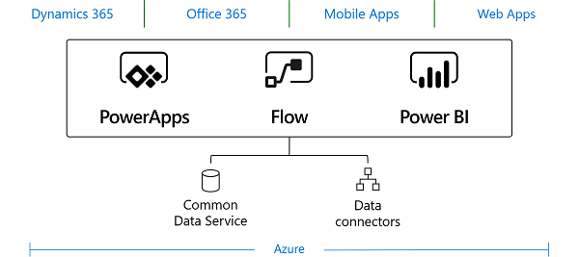

PowerApps:

Components:

* Admin Center;
* Home;
* Studio;
* Mobile App;
* Solid version control;
* **Data Import for Canvas app:**
  + From: Excel; SQL; SharePoint; etc.;
* **Vast connector:**
  + Databases, APIs, etc.;
* **App default structure:**
  + **Browse Screen:**
    - **Bar:**
      * Logo;
      * Refresh;
      * Search box;
      * Edit/Create;
      * Details;
      * Custom.
    - **Main Body (Browse Gallery):**
      * Table Row (from initial tabular data);
  + **Detail Screen:**
    - Detail form;
    - Custom.
  + **Edit Screen:**
    - Edit form;
    - Custom;
* **Personalize:**
  + Schema;
  + Camps;
  + If Logic (conditionals) + Excel Functions;
  + **Variables:**
    - Regular Variables (varName; something.Text);
    - **Tabular + Data Variables:**
      * Collections

**Model-driven apps:**

Components:

* **Data:**
  + Entity (contacts and accounts);
  + Field (text, number, date);
  + Relationship (how entities relate);
  + Option set field (lets user select from x options);
* **UI (user interface):**
  + App (components, properties, client type, URL);
  + Site map (navigation);
  + Form (data entry fields for an entity);
  + View (column shown, width for each, sort behavior);
* **Logic:**
  + Business process flow (walk users through a standard business process);
  + Workflow (automate business process without user interface);
  + Actions (manually invoke actions);
  + Business rule (applies rules or logic to a form to set field requirements);
  + MRCSTF flow (cloud-based service to create automated workflows);
* **Visualization:**
  + Chart;
  + Dashboard;
  + Embedded Microsoft Power BI;

**Common Data Services:**

Lets you securely store and manage data used by business apps.

Components:

* Stores in entities;
* Can connect to apps such as Dynamics, SharePoint, Excel, for app data;
* Uses **Logic Validation** (see previous page (minus MRCSTF Flow plus Business Logic with Code) ;
* **Entities:**
  + Each entity corresponds to a database table;
  + Each field (attribute) in an entity represents a column;
  + Mostly use standard, even if you need minor changes;
  + **Entity types:**
    - **Ownership:**
      * User or team owned: controlled at user level;
      * Organization-owned: controlled at organization level;
    - **Activity:**
      * Where a calendar entry can be made;
      * Have time-dimensions, data, can be opened, canceled or completed;
      * Can only be owned by a user/team.
      * Default activities are: appointment, email, fax, letter, phone call, recurring appointment, task;
    - **Custom entities:**
      * Others;
  + **Entity Relationships:**
    - One-to-many (parent-child relationship);
    - Many-to-many (peer relationship);

Microsoft Flow

Components:

* Used for automation and task management in apps;
* Has simple syntax/JSON like;
* Mobile functionality;
* **Vast functionality and templates:**
  + Examples: Twitter, Mail, Drive, GPS, Approval, Hybrid, Date, VS Code, MSCRST Dynamics, To-do (Wonderlist), If Logic (conditionals), Variables, Database (SQL Azure, SharePoint, etc.);
* UX and UI developed for management and keeping up with your Flows;
* Good problem solving and debugging interface;
* Fast Power App integration;
* **Flow details:**
  + Acionador e uma ou mais ações;

Power BI

Components:

* SaaS service;
* Able to be used in a company for consumer use and for structure use;
* **Elements:**
  + Power BI Desktop;
  + Power BI Service;
  + Power BI Mobile;
* **Purpose:**
  + Visualization
  + Dataset formation;
  + Data organization;
  + Data reports;
* **Multiple integrated data connectors:**
  + Excel;
  + SQL;
  + Azure;
  + Oracle;
  + Facebook;
* **Why use:**
  + For example, using Azure SQL Data Warehouse in-real-time tables that connect to other databases to create moment-by-moment datasets and data visualization;